Shulang Shen 941180473

Yameng Bing 941180283

The static gain of $G_{1}\left(s\right)$ is:

$$G_{1}\left(0\right)=1$$

The static gain of $G_{2}\left(s\right)$ is:

$$G_{2}\left(0\right)=0$$

The static gain means the steady state value of the output of a stable system for the unit step input.

$$y\left(t→∞\right)=\lim_{s→0}\left(s⋅Y\left(s\right)\right)=\lim_{s→0}\left(s⋅G\left(s\right)⋅\frac{1}{s}\right)=G\left(0\right)$$

The unit step responses of these 2 systems are:

Q1 codes:

We know that for a DC motor, we have the following relations:

1. Rotor electric circuit
$$V_{f}=R_{a}∙I+L_{a}∙\dot{I}$$

2. Torque equation
$$T_{l}=K_{m}∙I$$

3. Back EMF question

$$V_{f}=V-V_{b}$$

$$V_{b}=K_{b}∙ω$$

$$ω=\dot{θ}$$

It is given that $J\ddot{θ}+f\dot{θ}=T_{l}$

Rearranging the above questions we get :

So we can draw the following block diagram:

The transfer function $P\left(s\right)$ can be represented :

$$V=K_{b}∙sθ+R_{a}∙\frac{ Jθs^{2}+fθs}{K_{m}}+L_{a}∙\frac{ Jθs^{2}+fθs}{K_{m}}∙s$$

$$P\left(s\right)=\frac{θ\left(s\right)}{V\left(s\right)}=\frac{K_{m}}{R_{a}\left(Js^{2}+fs\right)+L_{a}s\left(Js^{2}+fs\right)+K_{m}K_{b}s}$$

Plugging in the coefficients and we get

$$P\left(s\right)=\frac{θ\left(s\right)}{V\left(s\right)}=\frac{0.0396}{6.8\left(0.06s^{2}+0.01s\right)+0.000620s\left(0.06s^{2}+0.01s\right)+0.0396*0.00646s}$$

We see that the value of $L_{a}$ is relatively small so we can neglect it and the equation

$$=\frac{0.0396}{0.408s^{2}+0.06826s}$$

The poles of the transfer function are $p_{1}=0$ and $p_{2}=-0.167$ one of the poles are at the origin so it is not stable.

Below are the 2 plots of $P\left(s\right)G_{1}\left(s\right)$ and $P\left(s\right)G_{2}(s)$ we can see that $P\left(s\right)G_{1}\left(s\right)$ is not stable while $P\left(s\right)G_{2}(s)$ is stable.

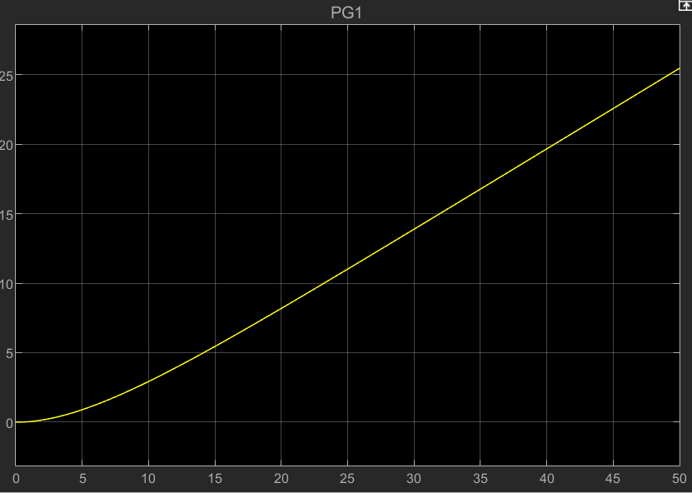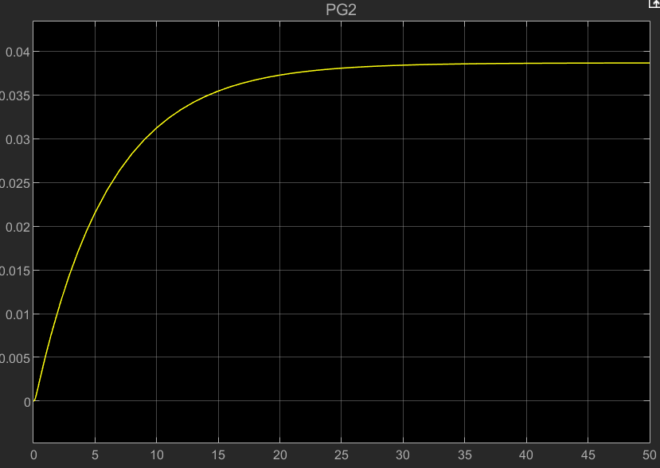

We see that compared to the results we obtained from part3, they are the same.

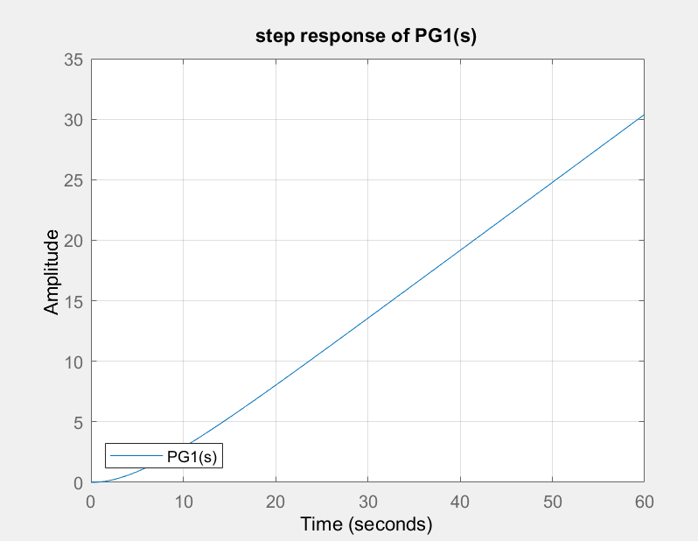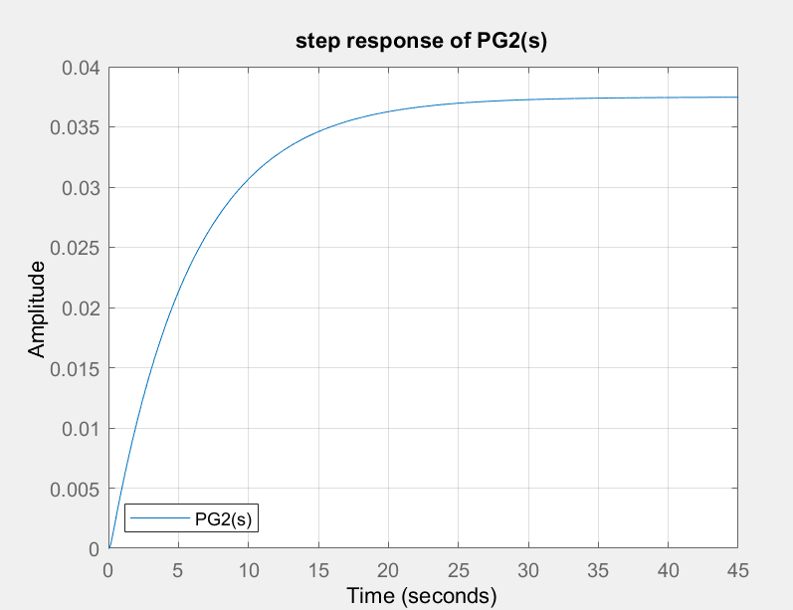

So the basic equations still hold and the following one changes into

$$ω=N_{r}\dot{θ}$$

It is given that

Rearranging the above questions we get :

$$V-V_{b}=R_{a}∙I+L_{a}∙\dot{I}$$

$$I=\frac{V-V_{b}}{R_{a}+L_{a}∙s}$$

$$ω=\frac{T_{l}}{Js+f}$$

$$θ=\frac{ωN_{r}}{s}$$

And the transfer function between V and $θ$ is:

$$P\left(s\right)=\frac{θ\left(s\right)}{V\left(s\right)}=\frac{N_{r}K_{m}}{JL_{a}s^{3}+\left(JR_{a}+fL_{a}\right)s^{2}+\left(fR_{a}+N_{r}^{2}K_{m}K_{b}\right)s}$$

Like before, the value of $L_{a}$ is relatively small and so the effect of it on the system is negligible. So it can be neglected.

Also, the plant is still unstable since it contains a pole $p=0$ which is not in the OLHP.